

**EECS 2311 Z - Software Development Project**

**Instructor:** Hung Viet Pham

**Team Number:** Group 3

**Project Name:** YU Path Builder

**Team Members:**

* Oyinkansola Fejuku
* Reuben Jaicks
* Wamiq Lakha
* Jostin Martinez Castillo
* Taha Usama

**YU Path Builder: Vision Statement**

The YU Path Builder system will be used to help university students plan their academic path across their entire degree, not just a single term. The system will allow students to view what they have taken in past semesters, what they are taking now, and what they plan to take in future semesters, and to organize these courses into a clear, visual multi-term plan from first year to graduation. Unlike existing timetable builders that focus on weekly schedules for one semester, YU Path Builder is designed to support long-term degree planning, including the ability to save and revisit plans over time and compare multiple academic paths without overwriting the student’s main plan.

The system will provide features for building and maintaining a degree plan, including saving multiple plans (e.g., “Plan A” and “Plan B”), adjusting future terms when a course is unavailable or delayed, and planning around constraints such as prerequisites, GPA requirements, and course eligibility. The system will also support planning preferences such as selecting a desired course load per term and indicating preferred semesters to study in (e.g., avoiding summer or reducing workload during certain terms). To reduce confusion and wasted effort, the system will help filter or highlight course options based on what the student has already completed and what they are eligible to take.

The system is primarily designed for use by York University undergraduate and graduate students who need a clearer way to plan toward graduation. Academic advisors may also use the system to assist students with course planning discussions. In the longer term, the system could be adapted for students at other universities with similar degree structures, and could provide insights for departments interested in understanding course demand trends if such reporting features are added in future versions.

In early versions of the system, official integration with university enrollment systems may not be available. As a result, the pre-release version may rely on simplified or manually entered data (e.g., a student entering completed courses or selecting courses from a limited catalogue) to demonstrate the planning workflow and timeline visualization. In future releases, the system could be extended to support richer course catalog data, improved eligibility checks, and more automated plan adjustments as more reliable data sources become available. This approach keeps the system functional early while remaining extensible for later improvements, similar to how sample systems describe simplified pre-release behavior and later expansion plans.

The use of a long-term degree planning tool is a significant improvement over current solutions that require students to plan with disconnected tools (single-term timetable builders, spreadsheets, and multiple web pages). By providing a single place to store past, current, and future plans, along with visual timelines and feasibility feedback (prerequisites, GPA constraints, and offering availability), the student’s workflow will be simplified and the time required to plan and revise an academic path will be reduced.

The project will be considered successful if students prefer YU Path Builder over their current planning process, as determined by brief user feedback (e.g., surveys or interviews), and if the system demonstrably supports end-to-end degree planning tasks. In particular, success will be shown if students can (1) create and save multi-term plans, (2) revisit and modify plans across time, (3) compare alternate paths, and (4) receive clear feedback when a plan is infeasible due to prerequisites, eligibility, GPA requirements, or course availability.

## **Big User Stories: YU Path Builder**

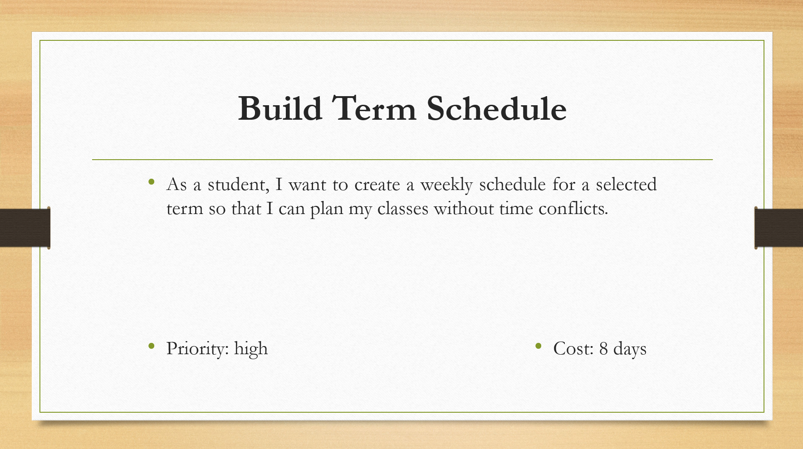

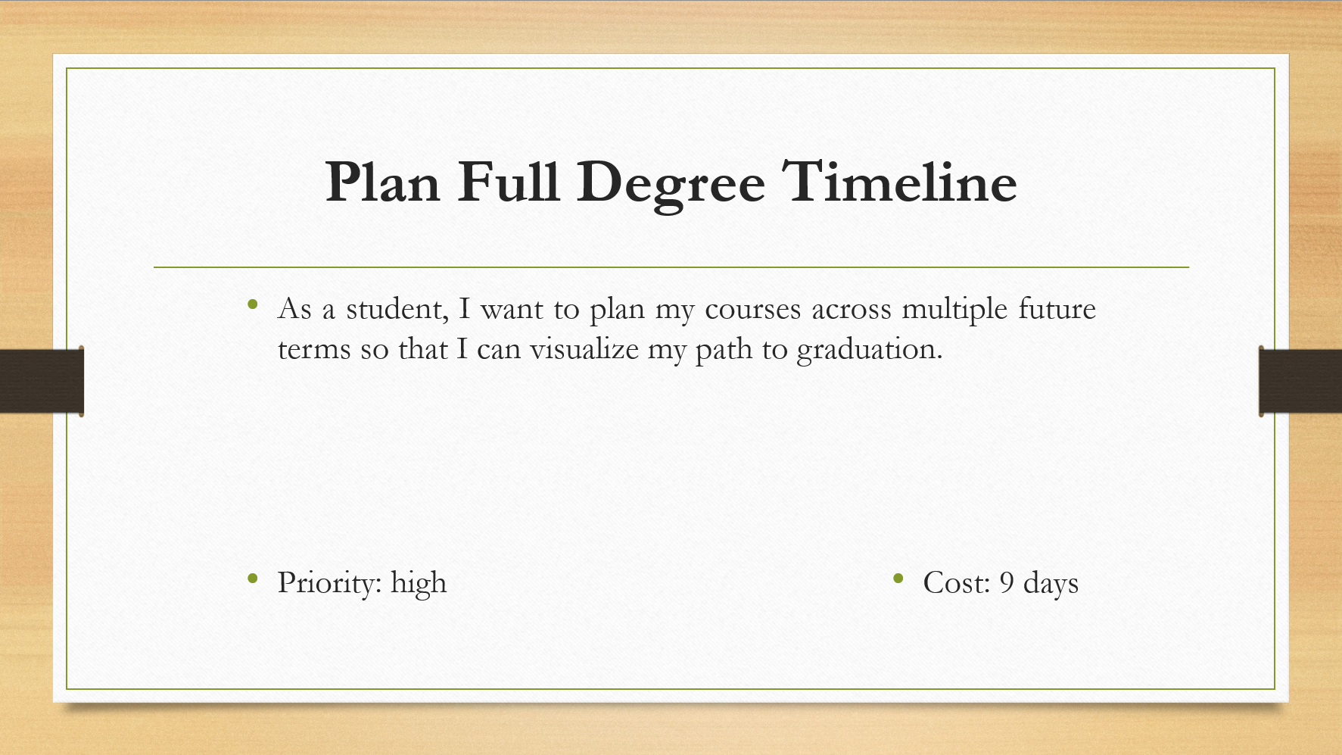

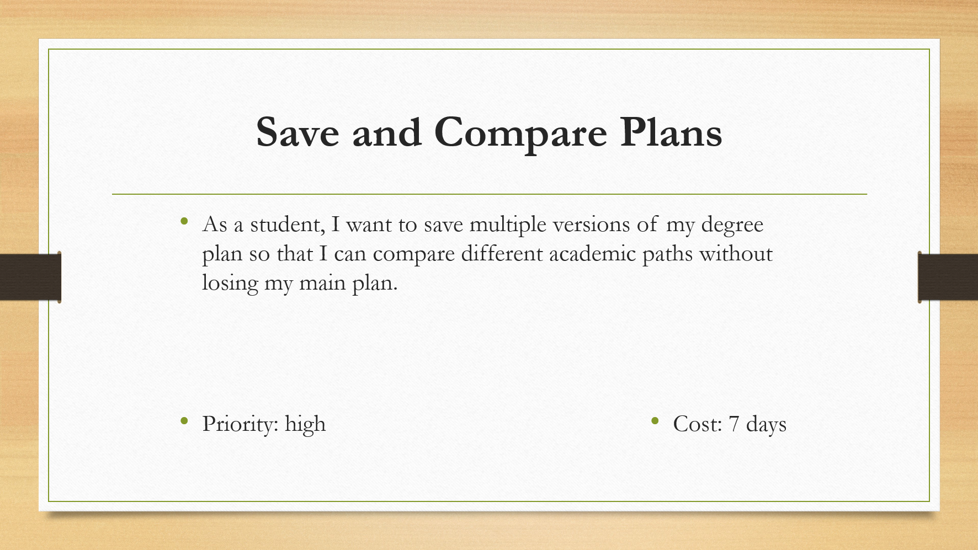

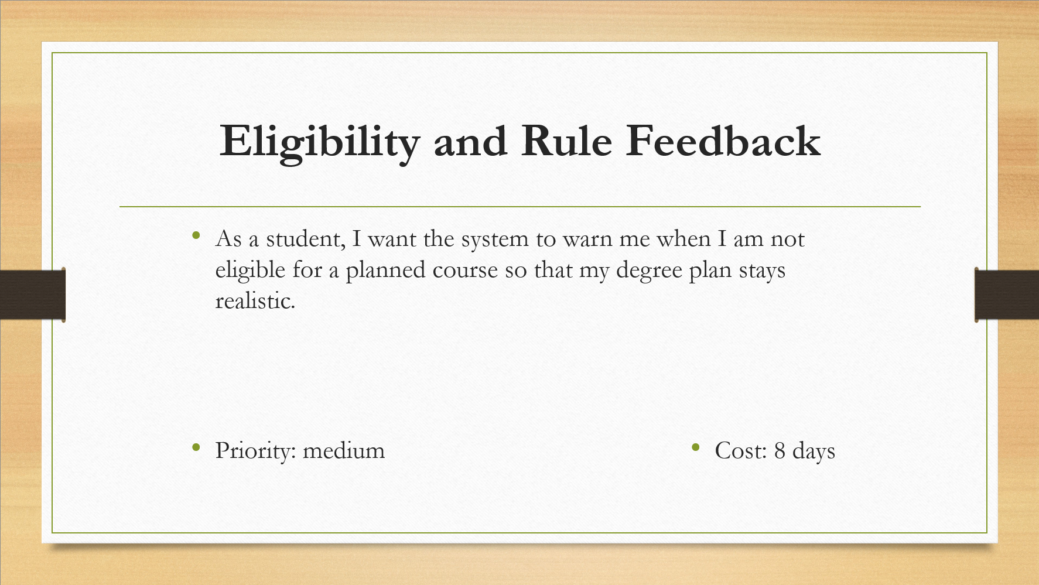

## **Iteration 1: Detailed User Stories (SRS-style)**

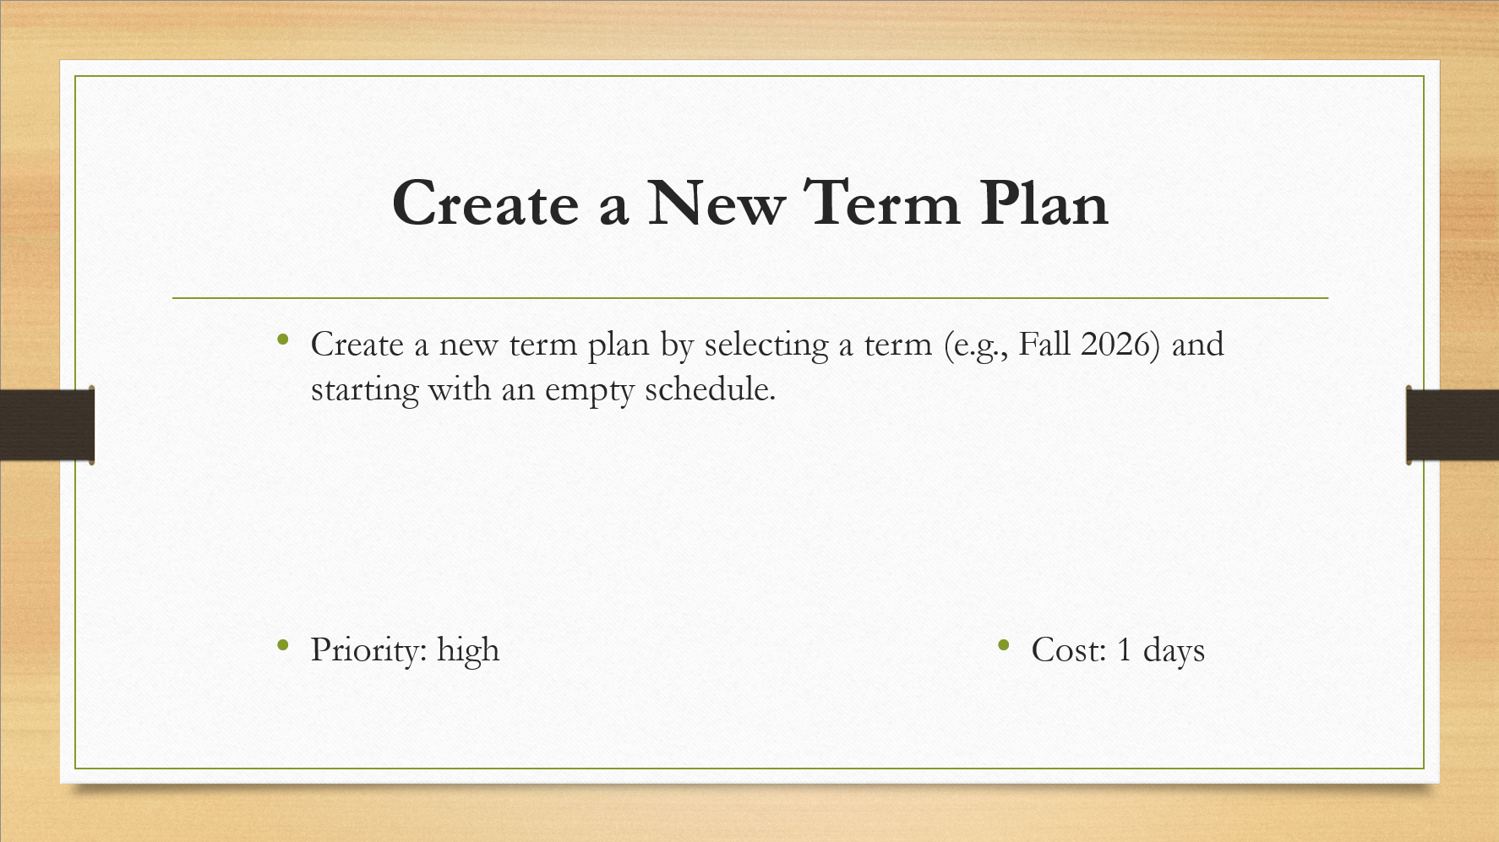

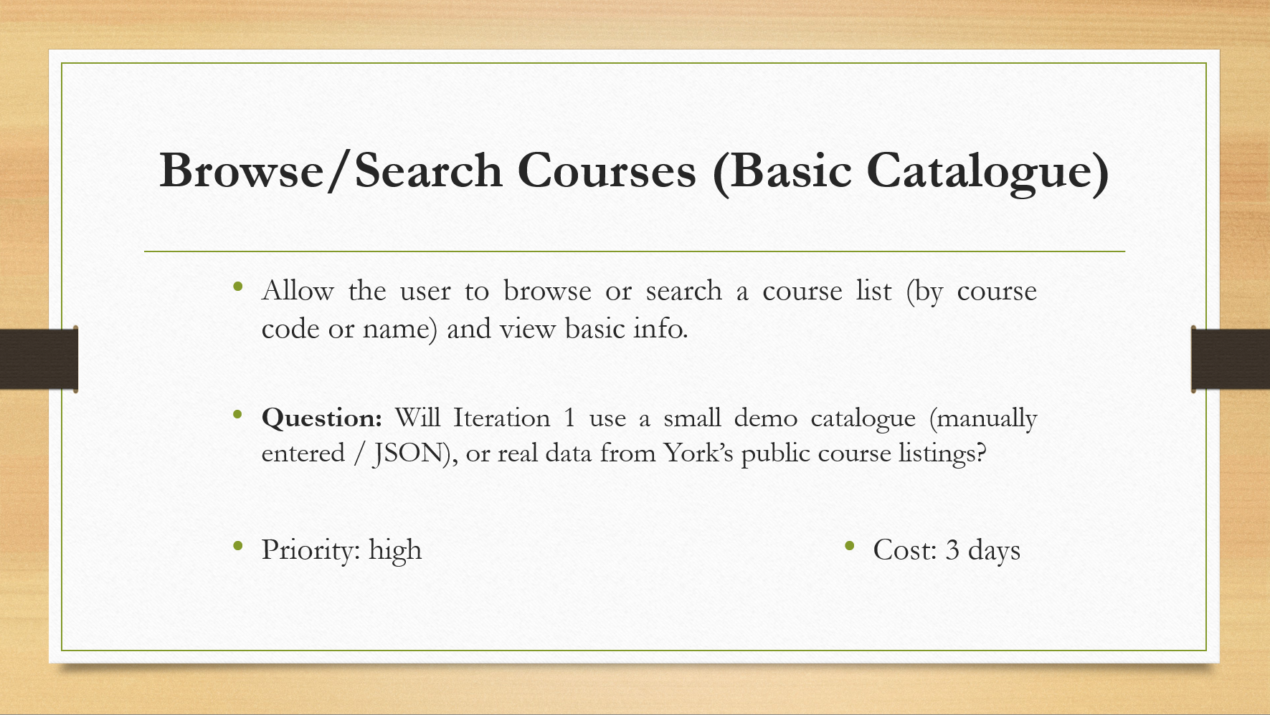

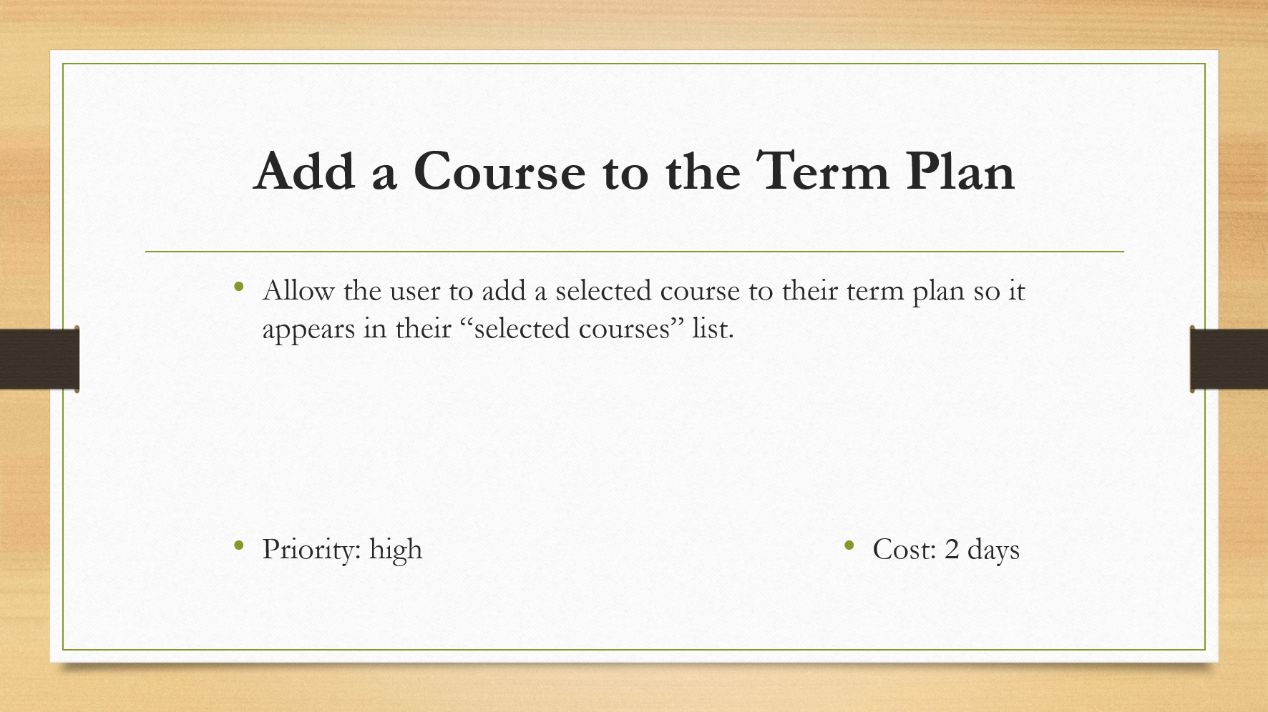

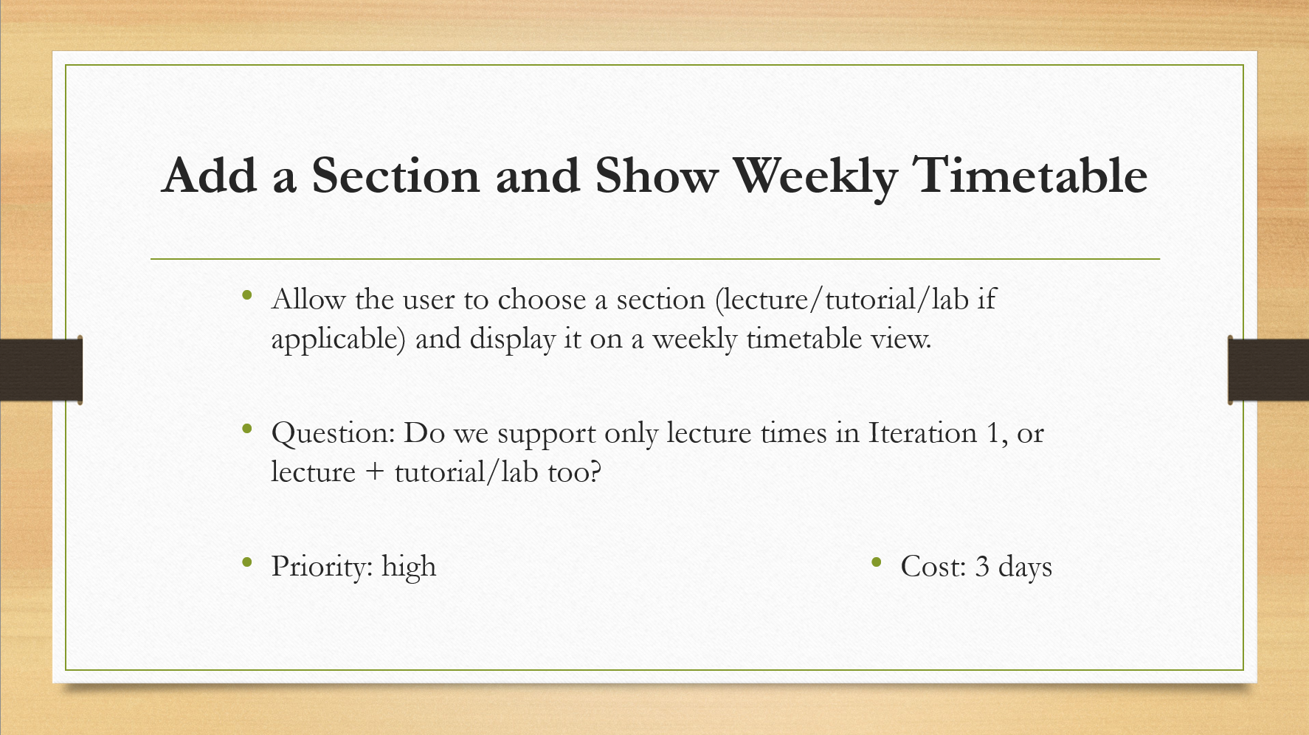

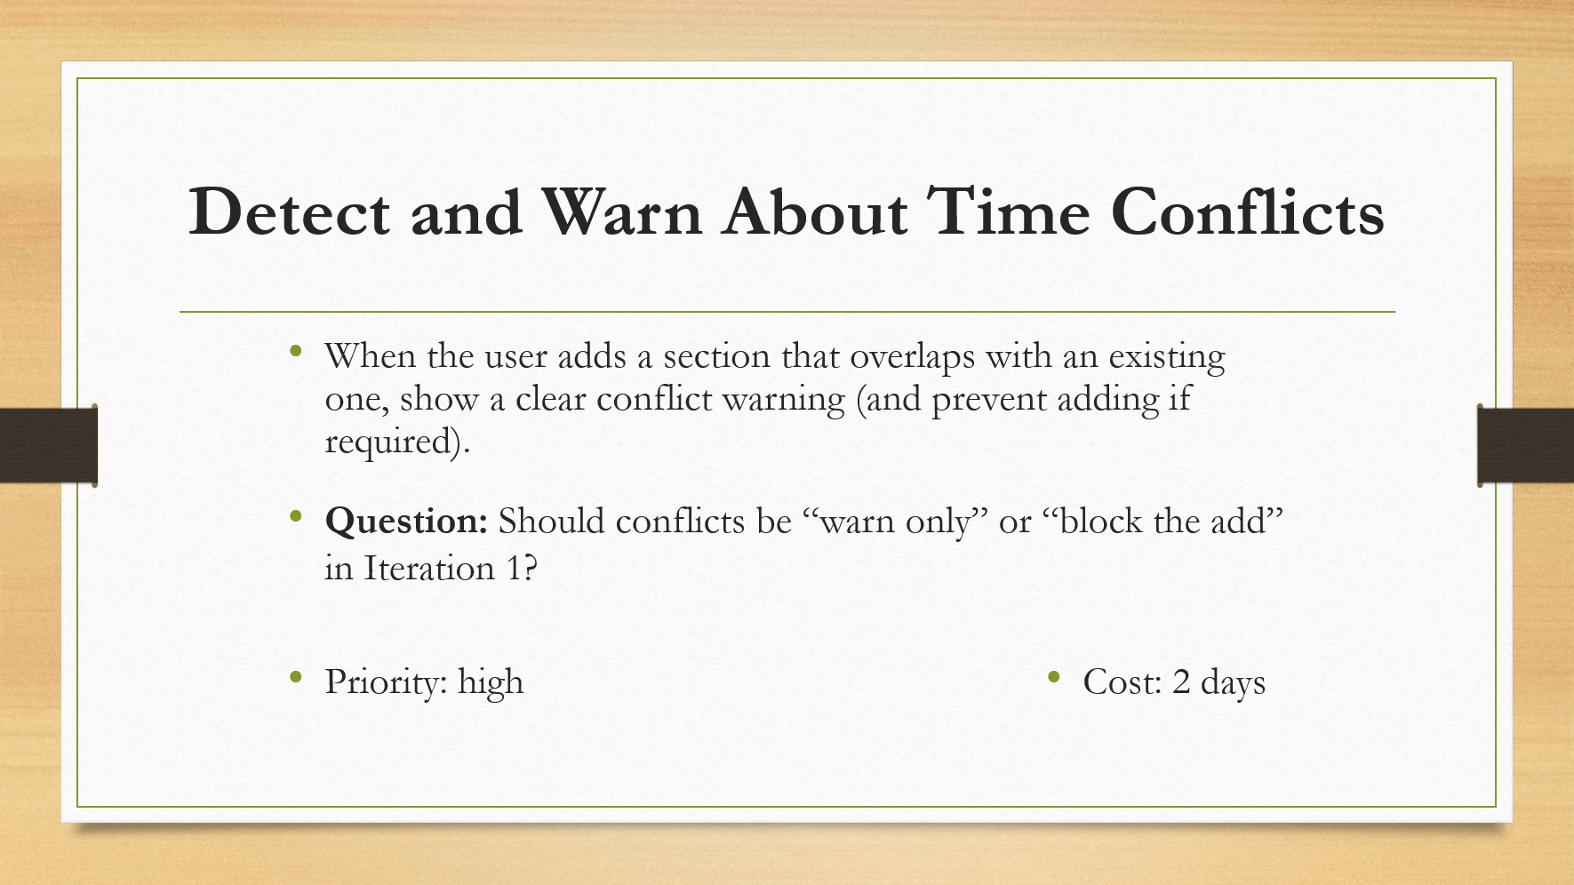

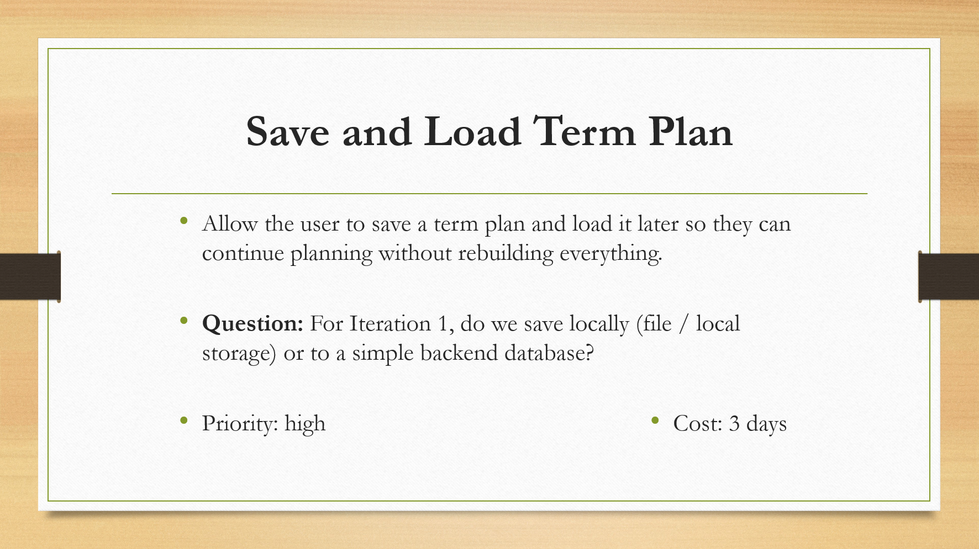

**Customer meeting’s summary video(max 5 mins)**

<https://drive.google.com/file/d/1PHo3s61ZlLvLb8gayTQWz9k66E76dJ77/view?usp=sharing>